Comparative Classifier Model Approach on Human Activity Recognition from Ambient Intelligence Dataset

Mahbuba Tasmin  
ID : 1610064042 Email: mahbuba.tasmin@northsouth.edu

Arif-Ur Rahman Chowdhury Suhan ID: 1610437642 Email: arif.suhan@northsouth.edu

Abdur Raufus Saleheen ID: 1610472642 Email: abdurraufus.saleheen@northsouth.edu  
Sharif Uddin Ruman  
ID: 1611557642 Email: sharif.ruman@northsouth.edu

Taoseef Ishtiak ID: 1612142642 Email: taoseef.ishtiak@northsouth.edu

Md. Sajid Ahmed  
ID: 1610364642  
Email: sajid.ahmed1@northsouth.edu   
N.M. Shihab Islam  
ID: 1420339042 Email: shihab.islam@northsouth.edu

Sifat Jahan ID: 1611702642 Email: sifat.jahan@northsouth.edu

Md. Shahnawaz Zulminan

ID: 1611708642 Email: shahnawaz.zulminan@northsouth.edu

*Abstract*— Human activity Recognition (HAR) systems are the key factor in futuristic smart living concept. Human activities are recorded as stream of sensor events in time-series or sequential dataset. HAR classifies the activities from a dataset through state-of-the-art classifier models built for time-series classification. This paper presents a comparative model approach on classification methods from the Ambient Sensor Dataset from UCI machine learning repository to recognize human activities. Before the classifier approach, we have executed extensive data preprocessing and feature selection to produce our selected dataset for the classification. The accuracy of the three classifier models (Decision Tree, Random Forest and Nearest Neighbor) shows different accuracy scores for datasets with and without feature selection. The research output of this paper presents the necessity of data preprocessing and significant feature selection for achieving greater accuracy score for noisy time-series data of HAR activity.

Keywords—Human Activity Recognition, Time Series Data, Activity Classification, Feature Engineering

# Introduction

Technology’s advancement has blessed mankind with smart world that consists of smart living appliances namely smart home devices, smartphones, wearables and other forms of applications, which has tremendously influenced human lifestyle and is continuing to shape the futuristic lifestyle as well. These technologies has empowered independent lifestyle of an individual, thus significantly reducing dependency on other people [3]. With these smart technologies, the concept of Ambient Assisted Living (AAL) emerged. Ambient Assisted Living [13] presents a system consisting of smart devices, home appliances, wireless networks primarily for healthcare monitoring and smart home living. This futuristic concept is working on to provide an independent and quality life primarily targeted for senior citizens. Another sister concept in this regard is Ambient Intelligence (AML). It presents the ability of a computing system to sense its surrounding and interact with people around. Both of these concepts originates from the advancement of Human Activity Recognition system on the infrastructure of networked sensors (Internet of Things). [14].

Data records from different sensor readings has paved the way to identify human activities separately and is leading to smart home systems consequently. Most HAR systems are based on camera or computer vision or wearable sensors [1].

Change detection in time-series data through calculating change in statistical metrics (e.g. Mean and Covariance) [2] assists in classifying activities. In general, activity recognition is a context-aware system [3]. It provides the understanding of the smart home applications to interpret and take action according to input from user interaction. Nevertheless, a real-time indoor HAR system is often limited by the constraints of indoor environments and makes it difficult to build a robust and scalable system.

Computer vision based HAR systems are useful for large sample of data and pedestrian movement. To eliminate the potential privacy issue related to camera based computer vision system, wearable sensors or devices including smartphones [6] are used as the data record and activity sensing infrastructure. This setup is sometime rendered restrained and potential limitations since the user need to always equip the sensing device while recording data, which doesn’t support seamless activity record process. In addition, the wearable approach requires transition between different positions of the user need to be perceived since the system depends on the target to determine the location of the wearable device with respect to the performed activity [17].

On the other hand, in the indoor environment, intelligent HAR system applies Ambient Intelligence to take action on the basis of the collected information from the surrounding and interacting residents [4, 5]. During recording, embedded sensors collects data readings of the users performing their activities being unaware of the system. Sensor-data is stored in a database and later analyzed to generate target information such as patterns, predictions and transitions [7]

This project work is motivated to classify five distinct activities (Watch TV, Read, Phone, Cook, and Eat) from the dataset of 12 pre-defined activities including unlabeled activity namely “other activity”, on the basis of the UCI Machine Learning Repository dataset “*Human Activity Recognition from Continuous Ambient Sensor Data Dataset*” from Washington State University [11]. The motivation is to precisely classify the activities while reducing the computational requirements through exhaustive data preparation. This originates from the idea to allow human activity recognition with less costs involved in computation so that we can incorporate the concept in the perspective of Bangladesh. The dataset is preprocessed, features with statistically significant values have been selected and finally we have applied three different classifier models to present a comparison output of the accuracy level.

The major contributions of the present paper include:

1. Data preprocessing of the selected 5-activities dataset through Principal Component Analysis and Linear Discriminant Analysis
2. Feature Selection based on statistical significance and importance score of columns from the datasets
3. Classifier models comparison on the pre-processed dataset

The paper follows the following structure: Section II presents the related works on Human Activity Recognition field. Section III presents Data Source and Section IV presents Methodology where data preprocessing and feature selection approaches are discussed and classifier model approach follows the discussion. Section V, Performance Evaluation consists of the results from three consecutive steps of the research and evaluation metric score of the classifiers. In the following Section VI, Conclusion ends the paper with overall discussion and future works for this project. The last section of this paper is Section VII References.

# Related Work

The research field of activity recognition is quite large considering the combination of embedded sensors, different environmental setups and algorithms to detect activity points. Hence, there are number of approaches explored in this field.

Probabilistic graph based Markov models, conditional random fields, Bayesian network [21, 12] are some of the state-of-the-art classification models for detecting activity from times-series data.

Distinct activities like Walking, Running, Standing, Sitting, Climbing Stairs and Falling) are classified in [13, 18] using accelerometer placed on the body. Recently smartphones with embedded motion detector and orientation sensors (Accelerometer and Gyroscope) are used as wearable device to recognize gesture and motion patterns [19].

In indoor HAR system, large range of activity is observed through embedded sensors at key location of activities. Environment sensors such as motion detector, light sensor, temperature and pressure sensors etc. are used to record stream of sensor data of activities in notable researches [4, 5].

At realistic activity recognition tasks, the recognizing activities are performed with interleaved activities [20, 21], embedded errors [19] and concurrent activities performed by multiple individuals in the setup [6, 20]. Detecting activities in free movement setup, where the residents perform usual daily routines in a smart home environment was the next step of advancement [3, 6]. These recorded datasets have required on manual labelling to segment and analyze the data.

Dedicated HAR architectures recognizes sequential and concurrent human activities using multiple sensor data at a time. Two key approaches are followed in HAR: “Data-Driven” and “Knowledge-Driven” technique [23]. Naïve Bayes (NB) classifiers, Decision Trees, Hidden Markov Models, Bayesian Networks and Support Vector Machine (SVM) classifier are the approaches in Data-driven method. Existing works including data-driven technique utilizes supervised approach using manually labeled data for training.

The unsupervised approaches achieve low performance in comparison with the supervised approach in indoor home environment. Activities are classified with the prior knowledge of pre-recorded data of surrounding. Data-driven techniques are useful for detecting basic distinctive activities, on the other hand unsupervised approach is suitable for creating probabilistic models with expected accuracy score.

# Data Source

The primary dataset of the project is collected from UCI Machine Learning Repository [11], *Human Activity Recognition from Continuous Ambient Sensor Data* *Dataset*. The dataset is fairly new, published on 20th September, 2019.

This dataset recorded multiple sensor data placed at volunteer resident houses where the residents performed their daily activities with no direct contact with the data collector infrastructure.

**Ambient PIR motion sensors, door/temperature sensors, and Light Switch sensors** are used to record activity data as event stream the sensors are located in different corners of resident houses to record event data.

The classification task is to predict the activity that is occurring in the smart home and being observed by the ambient sensors. The sensors communicate using the **ZigBee Pro protocol [5,6]**.

The original format captured from the sensors is provided, as well as the feature vector we generate using a sliding window of 30 sensor events. Each annotated data file (ex: csh101/csh101.ann.txt) has a corresponding feature vector CSV file (ex: csh101/csh101.ann.features.csv). Most of the sensor data files contain labels for **two months of the collection period**, though some contain labels for extended time periods. [4, 5, 11].

The motion sensors determines the time of motion occurrence in the range of the sensor. The motion sensor reports 1/0 depending on the record of motion activity. The transition period between on and off status is roughly 1.25 seconds. For continuous activity record beyond the threshold time, the sensor won’t record 0 until 1.25 seconds after the activity has ceased. One example smart home layout is attached in Figure 1.The key features of the scraped dataset for our purpose is presented in Table 1.

**Table 1: Key features of the Scraped Dataset**

|  |  |  |  |
| --- | --- | --- | --- |
| **Data Set Characteristics** | Multivariate, Sequential, Time Series | **Number of Instances** | 4475631 |
| **Attribute Characteristics** | Integer, Real | **Number of Attributes** | 37 |
| **Associated Tasks** | Classification | **Missing Values** | Yes |

The original dataset is collected under the lead of Diane J. Cook from School of Electrical Engineering and Computer Science at Washington State University, and the other creators are Aaron S. Crandall, and Brian L. Thomas.

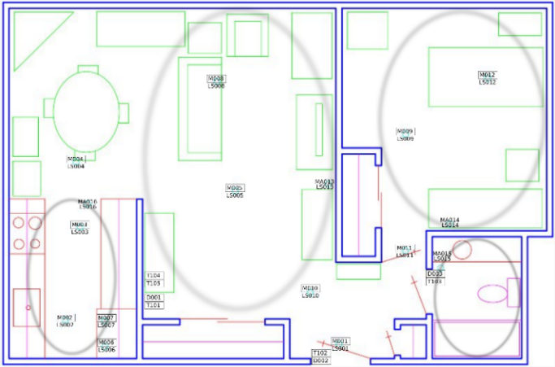

**Figure 1: Sensor Layout of One of the Volunteer Resident House**

# **Methodology**

We have scraped the dataset for this research from the UCI dataset, for the five selected activities (Watch TV, Read, Phone, Cook, and Eat). The dataset attributes is presented in table 1. The whole work is divided into three major segments- Data Preprocessing, Feature Selection and Classifier Model execution. In this section, we discuss about the working principle of each of the segment. Figure 2 presents the basic workflow of this project.

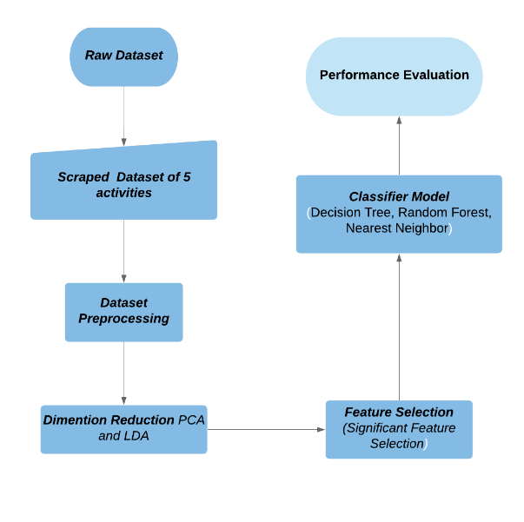

**Figure 2: Flowchart of Work**

## **Data Preprocessing**

The scraped dataset is standardized and divided into test and train set (split = 0.3). The scatter plot with test and train set marked in red and blue dot is presented in Figure 3.

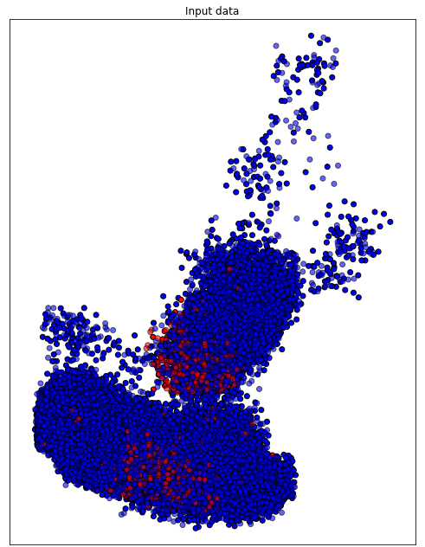

**Figure 3: Input Data Distribution of Test and Train Split**

## **Dimensionality Reduction**

We have applied dimensionality reduction on the dataset to reduce the high dimensional data into low-dimensional visually presentable clusters through Principal Component Analysis (PCA) and Linear Discriminant Analysis (LDA) methods

### Principal Component Analysis

Principal Component Analysis (PCA) applied to this data presents the most variant combination of principal components reduced from the original dataset. Figure 4 presents the PCA clustering applied on the original dataset.

The feature of the dataset is standardized first through

*StandardScaler( )* and reduced to dimension of 2. Here is the visual graph output of the dataset:

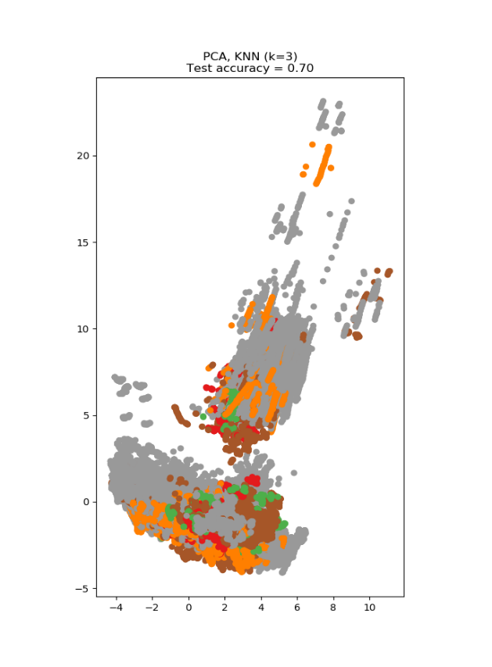

**Figure 4: PCA Presentation with 70% Accuracy**

The PCA variance presents 70% accuracy on the test dataset, which is significantly low since the dimensions are reduced from 37 to principal 2 dimensions.

### Linear Discriminant Analysis

Linear Discriminant Analysis (LDA) identifies attributes with most variance between classes. LDA is a supervised approach that uses known class labels.

The LDA accuracy score outperforms PCA score, with a 77% accuracy score in Figure 5. LDA finds centroid of each data point and projects the cluster of data points.

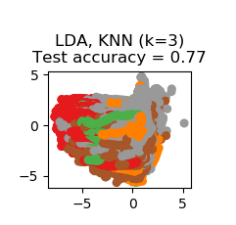

**Figure 5: LDA Presentation with 77% Accuracy**

## **Feature Selection**

This research work aims to execute activity detection through recognizing the pattern of data collected in “*Human Activity Recognition from Continuous Ambient Sensor Data Dataset*” [4, 11]. Primarily 5 distinct activities have been selected to train for pattern recognition purpose. Before fitting the dataset into the explored classifiers for activity recognition several preprocessing techniques have been applied for statistical analysis of the attributes the dataset to reduce those number of features that do not contribute to training. The research team believes the feature selection approach not only reduce the number of training time and computational cost but also will reduce the variance of the model, thus avoiding overfitting. The following section describes the feature selection techniques that the research team has applied for feature selection and the theoretical background of the techniques. Table 2 lists the set of significant column attributes calculated by the four feature selection approaches in the following:

### Low Variance Feature Removal:

The low variance feature selection technique removes the features which is found to be constant mostly. The constant value of a feature is not very interesting to find pattern and can be removed from the dataset. For dataset with large attributes the scikit-learn library automatically identifies the features which have the lowest variance. The heuristic approach before running the feature selection techniques is to use a threshold value to use as cut-off. The feature elimination is run when any features comes beneath this threshold value. On the given threshold the library computes the covariance against each tuple of the dataset and generates the result. The research team has kept a threshold of 80% as the threshold.

### L1 Based Feature Selection:

In SVM the parameter C determines the distribution of the vectors. The smaller C is the fewer features elected. L1 model outputs random value when working on large dataset. L1 model feature selection depends on noise level, smallest absolute value of non-zero coefficients, logarithmic number of features and design matrix structure. The design matrix must contain the property of not being too correlated.

### Tree-based Feature Selection:

The tree-based estimators are used to calculates the statistical significance of features and to discard the irrelevant features.

### Feature Selection with Random Forest:

Random forest classifier uses the tree-based strategies to rank the features for improving purity of the node.

**Table 2: Selected Features through Feature Selection Approach**

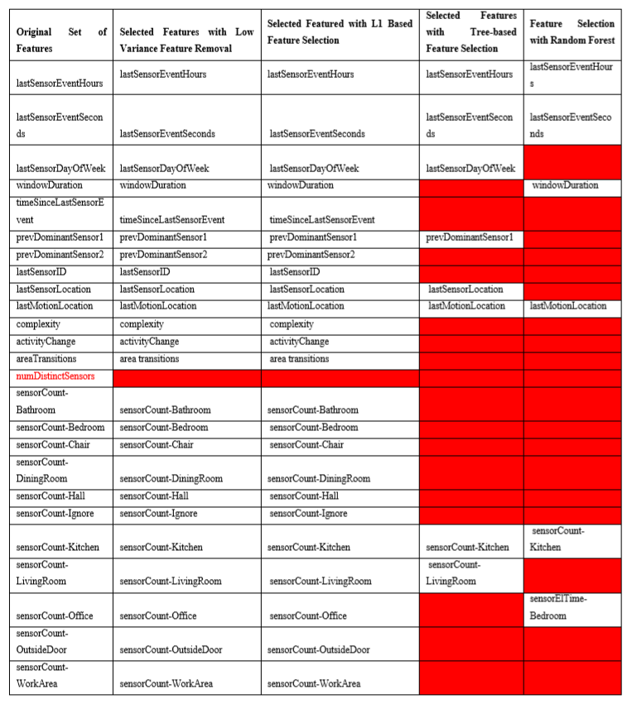

## **Feature Importance**

Feature importance calculates the score for each feature in a dataset through use of forests of trees. The red bars present the feature importance of the forest, along with inter-trees variability. Here we have applied the score calculation on 37 column attributes through Extra Tree Classifier and Random Forest Classifier. Figure 6 & 7 presents the significant features with bar charts and the scores are listed in table 3 & 4 respectively.

### **Extra Tree Classifier**

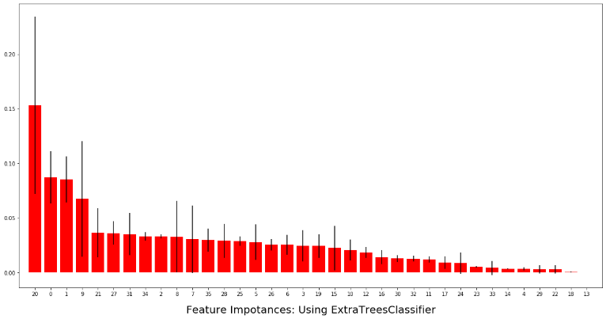

**Figure 6: Extra Tree Classifier Feature Score**

**Table 3: Top 10 Significant feature score in Extra Tree Classifier**

|  |  |
| --- | --- |
| Feature | Score |
| 1. feature 20 | (0.153283) |
| 2. feature 0 | (0.087287) |
| 3. feature 1 | (0.085212) |
| 4. feature 9 | (0.067567) |
| 5. feature 21 | (0.036598) |
| 6. feature 27 | (0.036238) |
| 7. feature 31 | (0.035192) |
| 8. feature 34 | (0.033122) |
| 9. feature 2 | (0.033049) |

### **Random Forest Classifier**

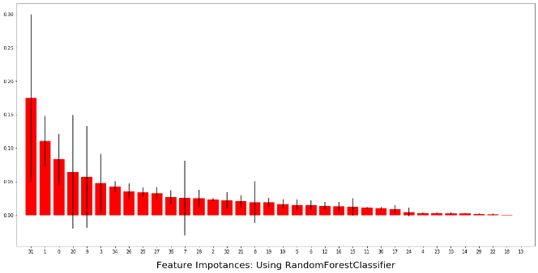

**Figure 7: Random Forest Classifier Feature Score**

**Table 4: Top 10 Significant feature score in Random Forest Classifier**

|  |  |
| --- | --- |
| Feature | Score |
| 1. feature 31 | (0.149931) |
| 2. feature 1 | (0.116110) |
| 3. feature 20 | (0.091917) |
| 4. feature 0 | (0.080503) |
| 5. feature 3 | (0.055434) |
| 6. feature 9 | (0.045336) |
| 7. feature 34 | (0.041218) |
| 8. feature 25 | (0.035567) |
| 9. feature 26 | (0.035500) |
| 10. feature 27 | (0.031554) |

## **Backward Elimination Output**

Using Variance Threshold baseline approach, we have executed Backward Elimination algorithm on the dataset,

The two columns that are found most significant through this technique are “lastSensorEventSeconds, sensorElTime-Bedroom.” Figure 8 presents the statistical significance calculation of each of the column attributes with respective to p-value, t-test and standard error.

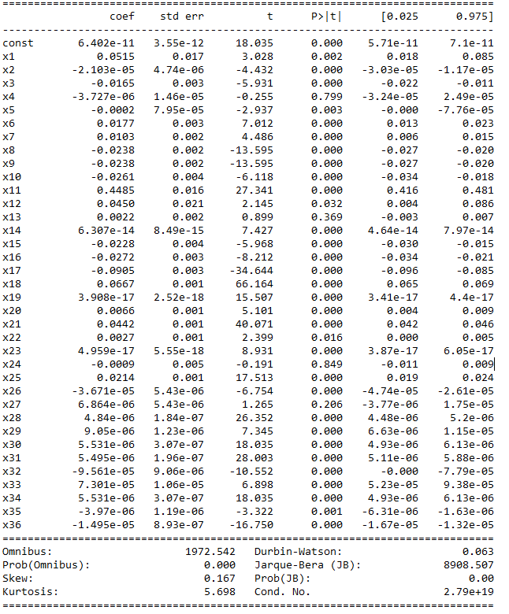

**Figure 8: Backward Elimination Output**

## **Classifier Comparison**

The classifier comparison presents a set of classifying methods in scikit-learn on our dataset. The point of this comparison is to illustrate the nature of decision boundaries of different classifiers. After feature selection is done, two datasets are generated based on the Tree-based and Random-forest based feature selection. The L1-based and Low-variance approach don’t reduce the dimension significantly and hence we have discarded those results.

We have tested on **Nearest Neighbor, Decision Tree and Random Forest Classifiers** to run on the two datasets.

# **Performance evaluation**

In this section, three state-of-the art classifier models for HAR system is applied on the raw dataset and the preprocessed dataset. Three model applied here are Decision Tree, Nearest Neighbor and Random Forest. The results clearly show an increase of 5%-10% on accuracy varying on models when dataset is pre-processed and significant features are selected. Later in this section, we present the confusion matrix of each of the classifier models on the dataset and statistical metric score to compare and evaluate the model performance.

## **Dataset without Feature Selection**

First, we have run the classifier models in the dataset without feature selection approach. The Figures 9-11 represent the model accuracy of Decision Tree, Nearest Neighbor and Random Forest respectively on the dataset.

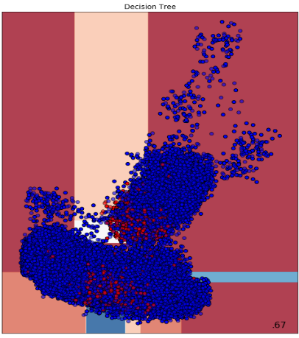

**Figure 9: Decision Tree Accuracy 67%**

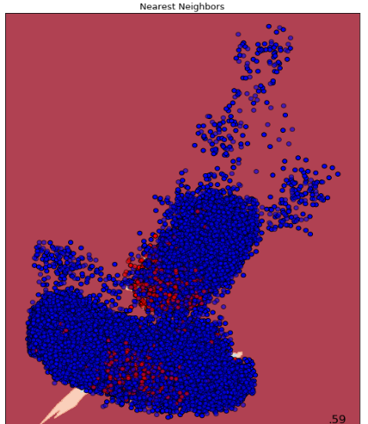

**Figure 10: Nearest Neighbor Accuracy 59%**

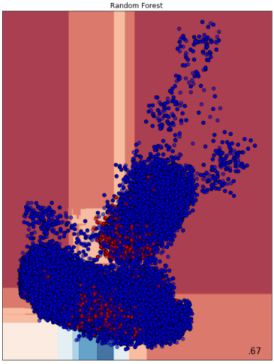

**Figure 11: Random Forest Accuracy 67%**

## **Dataset from Tree-based Classifier Feature Selection**

The tree-based classifier feature selection selects top few attributes and produces a new dataset based on the selection. Figure 12-15 represent the new dataset distribution based on the selection and the following classifier models (Decision Tree, Nearest Neighbor and Random Forest respectively) accuracy scores. The distribution pattern in Figure 12 is significantly different and denser compared to the input distribution of the dataset without feature selection in Figure 3.

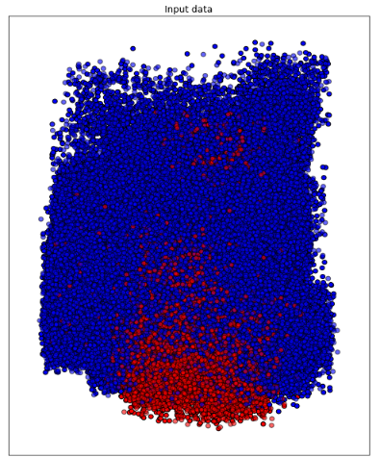

**Figure 12: Input Data Distribution of Tree-based Feature Selection**

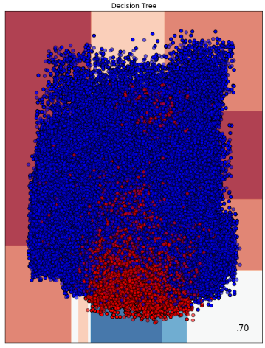

**Figure 13: Decision Tree Accuracy 70%**

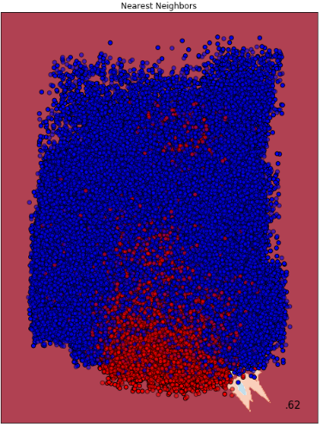

**Figure 14: Nearest Neighbor Accuracy 62%**

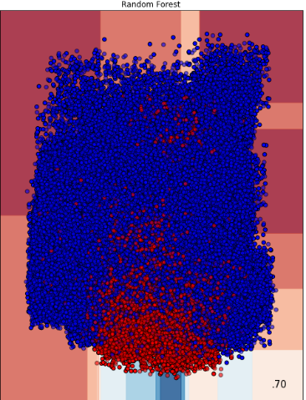

**Figure 15: Random Forest Accuracy 70%**

## **Dataset From Random Forest Selection Classifier Feature Selection**

The Random-forest selection classifier feature selection selects top few attributes and produces a new dataset based on the selection. Figures 16-19 represent the new dataset distribution based on the selection and the following classifier models (Decision Tree, Nearest Neighbor and Random Forest respectively) accuracy scores.

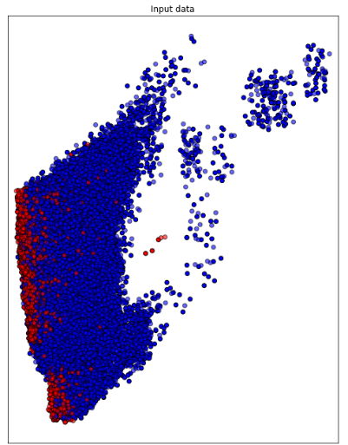

**Figure 16: Input Distribution of Random-Forest Based Feature Selection**

**.**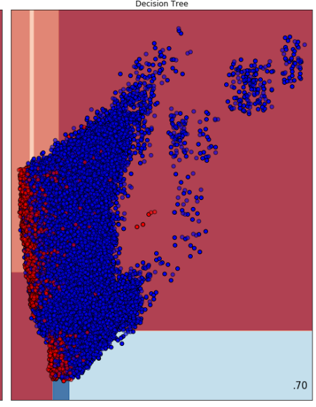

**Figure 17: Decision Tree Accuracy 70%**

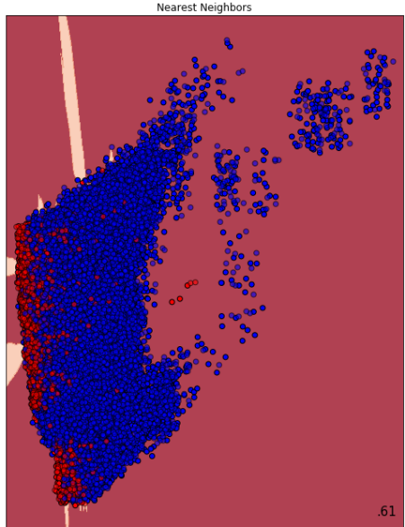

**Figure 18: Nearest Neighbor Accuracy 61%**

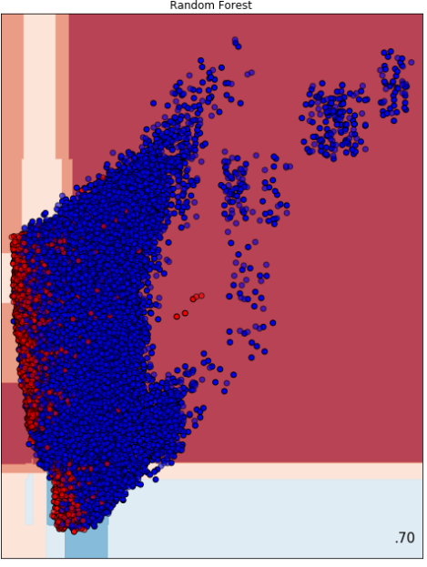

**Figure 19: Random Forest Accuracy 70%**

Table 5 summarizes the performance of the three different classifier models on the 3 datasets.

**Table 5: Accuracy Score of Classifier Models on Three Datasets**

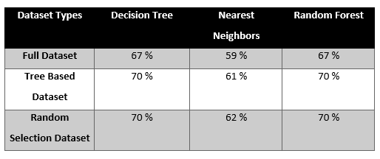

## Evaluation Metrics

The performance of the three classifier model on 3 datasets is evaluated through four key metrics of accuracy: *precision, recall, f1-score and support*. We have applied the classifier models on the raw dataset as well as the feature selected two other datasets. The confusion matrix and evaluation metrics are presented here on the basis of the different datasets and the result of classification models on those datasets. The activities are coded into numerical values in here, hence the below graphs will show activity id comparisons.

Accuracy gives the sum of correct classifications to the total number of instances.

Accuracy =

Where TP i.e. true positive is the category of positive attributes correctly classified as positive attributes, TN i.e. true negative is the set of negative samples identified as negative samples. FP i.e. false positive is the category of negative attributes classified as positive attributes. And FN i.e. false negative are the positive samples being classified as negative samples.

The formula for Precision =

This performance metric presents the proportion of positive attributes those were classified correctly. Recall presents the proportion of actual positive classes those were identified in proportion to all samples in the actual class

The formula for Recall =

F1-score is a performance metric that measures the weighted harmonic mean of precision and recall. It is used to evaluate the classification accuracy of an algorithm.

F−Score=2*

### Full Dataset Metric Scores

In this sub-section, three confusion matrix and respective statistical scores are presented on the basis of the three classifier model applied on the dataset without significant feature selection. Figure 20 presents the PCA clustering of the full dataset.

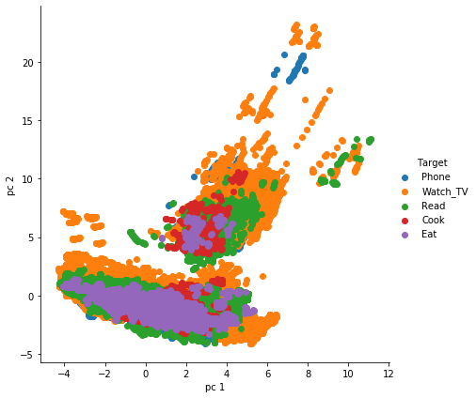

**Figure 20: PCA Clustering of Full Dataset**

#### Decision Tree

The evaluation metrics show that decision tree worked fairly well for activity 2 and activity 4, with a weighted average accuracy of 67% in figure 21. For activity 0, 1 and 3, values are zero or near to zero. This represents that decision tree didn’t work so well on the full dataset.

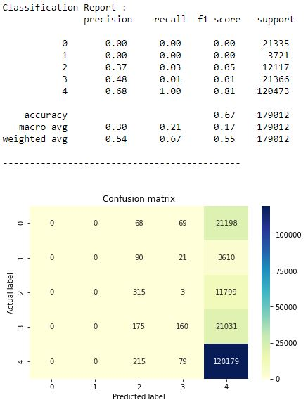

**Figure 21: Decision Tree Confusion Matrix and Evaluation Scores on Full Dataset**

#### Nearest Neighbor

The evaluation metrics show that compared to decision tree, nearest neighbor worked fairly well for all 5 activities as shown in figure 22. The f1-score ranging from 0.76 for activity-4 to the least 0.04 for activity-1 presents a moderate performance of the model on the dataset. The overall accuracy stands to 59% in this case.

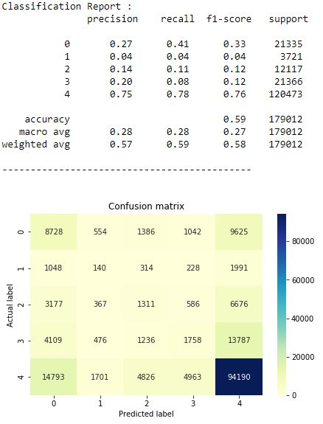

**Figure 22: Nearest Neighbor Confusion Matrix and Evaluation Scores on Full Dataset**

#### Random Forest

In this case, the evaluation metric showed quite surprising results in terms of zero f1-score for all 4 activities and 81% for activity-4. All the evaluation metrics through Random forest classifier only could classify activity 4 fairly well. The overall accuracy is 67% as presented in figure 23.

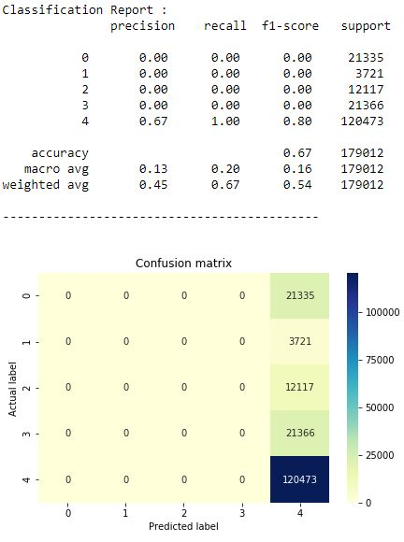

**Figure 23: Random Forest Confusion Matrix and Evaluation Scores on Full Dataset**

### Random Forest Feature Select Dataset

In this sub-section, the dataset in execution consists of the selected statistically significant attributes from Random Forest Feature Select approach on the full dataset. Three classier models have been executed and evaluation metric scores of each one of those is discussed below. Figure 24 presents the PCA clustering of this feature selected dataset.

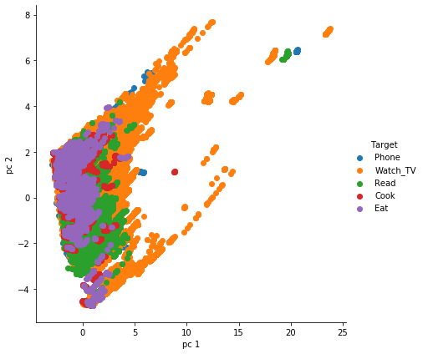

**Figure 24: PCA Clustering of Feature Selected Dataset**

#### Decision Tree

Unlikely the first iteration of Decision Tree on full dataset, the model performs better in the Random Forest Feature Selected Dataset. The overall accuracy here is 70%, while the F1-score goes 81% as maximum for activity 4. Precision, Recall and F1-score- each metric has 1 pair of zero values for activity 1 & 2. Figure 25 presents the confusion matrix for this classifier model on the feature selected dataset.

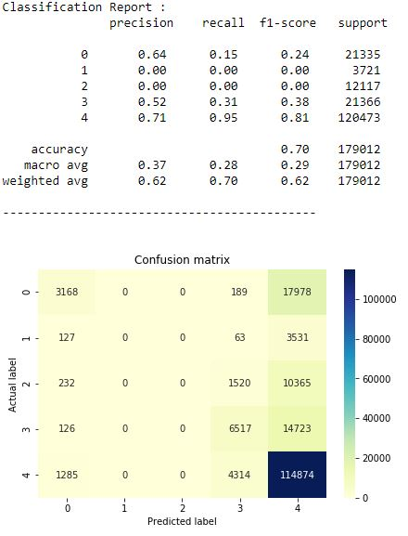

**Figure 25: Decision Tree Confusion Matrix and Evaluation Scores on Random Forest Feature Select Dataset**

#### Nearest Neighbor

Nearest Neighbor classifier on Random Forest feature select dataset produces overall accuracy of 61%, while the F1-score, Precision and Recall metrics here produces values more than zero for all the activities. The highest metric score goes to activity-4 in all three metrics, as presented in Figure 26.

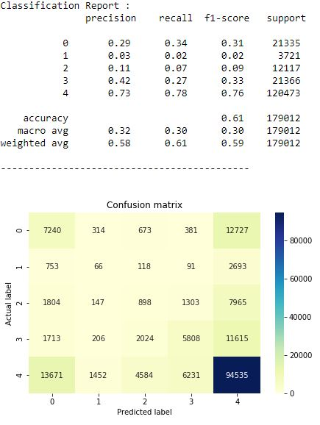

**Figure 26: Nearest Neighbor Confusion Matrix and Evaluation Scores on Random Forest Feature Select Dataset**

#### Random Forest

Random forest classifier on this dataset produces an overall accuracy of 70%. The outputs here have a strong similarity with the Decision Tree result on the same dataset, with 1%-2% difference for metric scores recorded at each activity. The findings are presented in figure 27.

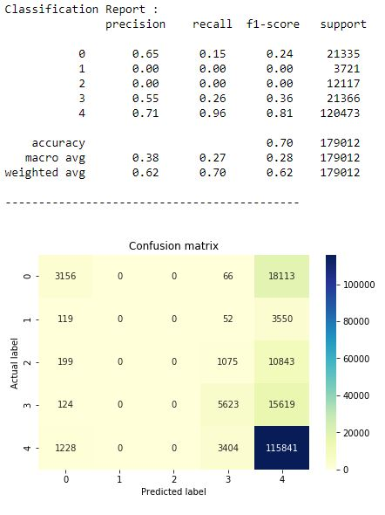

**Figure 27: Random Forest Confusion Matrix and Evaluation Scores on Random Forest Feature Select Dataset**

### Tree based Feature Select Dataset

In this sub-section, the dataset in execution consists of the selected statistically significant attributes from Tree Based Feature Select approach on the full dataset. Three classier models have been executed and evaluation metric scores of each one of those is discussed below. Figure 28 presents the PCA clustering of this dataset.

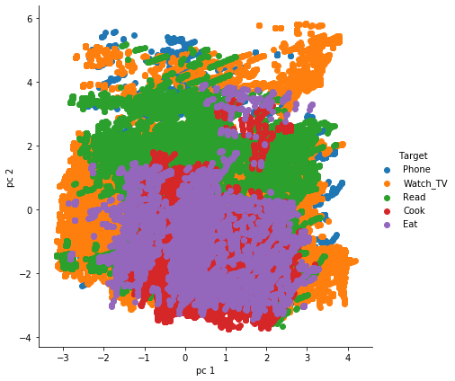

**Figure 28: PCA Clustering on Tree Based Feature Select Dataset**

#### Decision Tree

The overall accuracy of Decision Tree on this dataset is 70%, while the F1-score goes 82% as maximum for activity 4. Precision, Recall and F1-score- each metric has 1 pair of zero values for activity 1 & 2, similar to the decision tree result on random forest based feature selected dataset. The confusion matrix is presented in figure 29.

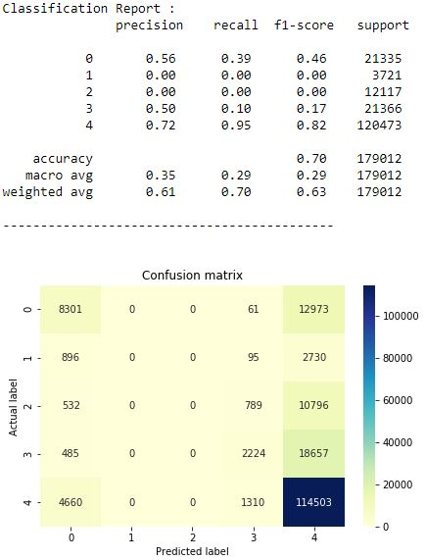

**Figure 29: Decision Tree Confusion Matrix and Evaluation Scores on Tree Based Feature Select Dataset**

#### Nearest Neighbor

Nearest Neighbor Classifier on this dataset achieves 62% overall accuracy. All the metric score are consistently measured for all activities. Nearest neighbor showed the consistent output of being able to classify correctly all the activities across all three datasets. Figure 30 presents the evaluation metric score and confusion matrix here.

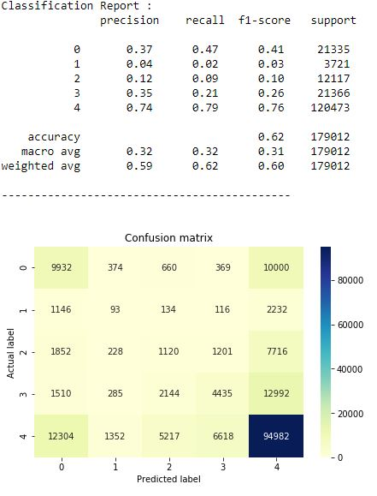

**Figure 30: Nearest Neighbor Confusion Matrix and Evaluation Scores on Tree Based Feature Select Dataset**

#### Random Forest

Random forest classifier on this dataset achieves an overall accuracy of 70%, as shown in figure 31. In this dataset too, activities 1 & 2 have achieved zero metric score across all three evaluation metrics on Random Forest.

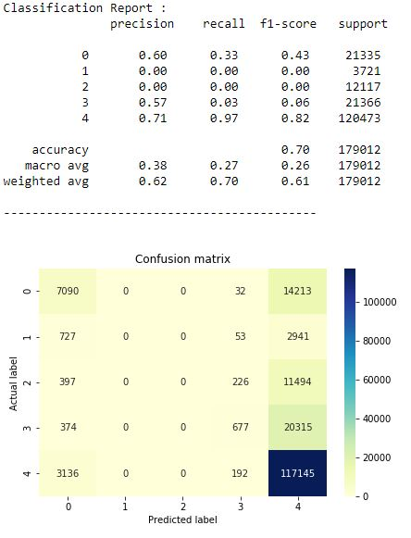

**Figure 31: Random Forest Confusion Matrix and Evaluation Scores on Tree Based Feature Select Dataset**

On the basis of these nine analysis, Nearest Neighbor has proved to be the overall best classifier for these three datasets, on the classifying ability of five listed activities.

# Conclusion

In this paper, we present a comparative model approach to classify five selected activities from the dataset. The classifier models show significant changes after application of precise data preprocessing and feature selection approach. The accuracy score increased by 10% using Decision Tree from the raw dataset when feature selection is applied. From the three classifier state-of-the-art model for human activity recognition, we have utilized here Decision Tree, Random Forest and Nearest Neighbor. Only the Nearest Neighbor classifier has persistently detected all five activities with varying metric score in the three datasets of this research. On the raw dataset without prior feature selection based on feature significance calculation, Nearest Neighbor achieved 59% overall accuracy, which increased to 61% in Tree based feature selected dataset and 62% in Random Forest based dataset. Hence, this research paper presents that for human activity recognition systems, data preprocessing and feature selection greatly affects the classification performance and consequently the AAL and AML structures on the basis of HAR. State-of-the-art classifier models have presented varying accuracy score on the basis of how well the dataset have been preprocessed for running machine learning model on the dataset.

The future work includes preparing neural network approach to classify the activities and on the basis of the model, we aim to produce a robust time-series model to handle adversarial attack.

The end goal of the research work is to inject adversarial attack on the model to confuse the network and identify the actual activity after the injection. To suggest more amicable work based on such data, the research team is exploring variety of fields in health, administration and security issues where such dataset generation and model implementation will be useful for activity recognition.

# REferences

1. G. A. Oguntala et al., "SmartWall: Novel RFID-Enabled Ambient Human Activity Recognition Using Machine Learning for Unobtrusive Health Monitoring," in IEEE Access, vol. 7, pp. 68022-68033, 2019. doi: 10.1109/ACCESS.2019.2917125
2. D. Cook, N. Krishnan, and P. Rashidi. Activity discovery and activity recognition: A new partnership. IEEE Transactions on Systems, Man, and Cybernetics, Part B, 43(3):820-828, 2013
3. Reisburg B, Finkel S, Overall J, Schmidt-Gollas N, Kanowski S, Lehfeld H, Hulla F, Sclan SG, Wilms HU, Heininger K, Hindmarch I, Stemmler M, Poon L, Kluger A, Cooler C, Bergener M, Hugonot-Diener L, robert PH, Erzigkeit H. The Alzheimer’s disease activities of daily living international scale (ADL-IS) International Psychogeriatrics. 2001;13(2):163–181
4. S. Aminikhanghahi, T. Wang, and D. Cook. Real-time change point detection with application to smart home time series data. IEEE Transactions on Knowledge and Data Engineering, to appear
5. S. Aminikhanghahi and D. Cook. Enhancing activity recognition using CPD-based activity segmentation. Pervasive and Mobile Computing, 53:75-89, 2019
6. A. Alberdi, A. Weakley, A. Goenaga, M. Schmitter-Edgecombe, and D. Cook. Automatic assessment of functional health decline in older adults based on smart home data. Journal of Biomedical Informatics, 18:119-130, 2018
7. Brdiczka O, Crowley JL, Reignier P. Learning situation models in a smart home. IEEE Transactions on Systems, Man, and Cybernetics, Part B. 2009;39(1)
8. B. Minor, J. Doppa, and D. Cook. Learning activity predictors from sensor data: Algorithms, evaluation, and applications. IEEE Transactions on Knowledge and Data Engineering, 29(12):2744-2757, 2017
9. Logan B, Healey J, Philipose M, Tapia EM, Intille S. A long-term evaluation of sensing modalities for activity recognition. Proceedings of the International Conference on Ubiquitous Computing; 200
10. Gu T, Chen S, Tao X, Lu J. An unsupervised approach to activity recognition and segmentation based on object-use fingerprints. Data and Knowledge Engineering. 2010
11. P. Alinia, C. Cain, R. Fallahzadeh, A. Shahrokni, and H. Ghasemzadeh. How accurate is your activity tracker? A comparative study of step counts in low-intensity physical activities. Journal of Medical Internet Research, 5(8):e106, 2017
12. K. Feuz, and D. Cook. Modeling skewed class distributions by reshaping the concept space. AAAI Conference on Artificial Intelligence, 2017
13. J.-L. Reyes-Ortiz, L. Oneto, A. Samà, X. Parra, and D. Anguita,“Transition-Aware Human Activity Recognition Using Smartphones,” Neurocomputing, vol. 171, pp. 754–767, Jan. 2016
14. Q. Ni, A. B. García Hernando, and I. P. de la Cruz, “The Elderly’s Independent Living in Smart Homes: A Characterization of Activities and Sensing Infrastructure Survey to Facilitate Services Development.” Sensors. vol. 15, no. 5, pp. 11312–62, May 2015.
15. “Welcome to CASAS.” [Online]. Available: http://casas.wsu.edu/datasets/. [Accessed: 24-Apr-2018].
16. Lara, Oscar & Labrador, Miguel. (2013). A Survey on Human Activity Recognition Using Wearable Sensors. Communications Surveys & Tutorials, IEEE. 15. 1192-1209. 10.1109/SURV.2012.110112.00192.
17. Davis-Owusu, Kadian & Owusu, Evans & Bastani, Vahid & Marcenaro, Lucio & Hu, Jun & Regazzoni, Carlo & Feijs, Loe. (2016). Activity recognition based on inertial sensors for Ambient Assisted Living.
18. B. Najafi, K. Aminian, A. Paraschiv-Ionescu, F. Loew, C. J. B¨ula, and P. Robert, “Ambulatory system for human motion analysis using a kinematic sensor: monitoring of daily physical activity in the elderly,” Biomedical Engineering, IEEE Transactions on, vol. 50, no. 6, pp. 711–723, 2003.
19. Assessing the quality of activities in a smart environment. Cook DJ, Schmitter-Edgecombe M Methods Inf Med. 2009; 48(5):480-5
20. N. A. Capela, E. D. Lemaire, and N. Baddour, “Feature selection for wearable smartphone-based human activity recognition with able bodied, elderly, and stroke patients,” PloS one, vol. 10, no. 4, p. e0124414, 2015.
21. K. Davis, E. Owusu, C. Regazzoni, L. Marcenaro, L. Feijs, and J. Hu,“Perception of human activities a means to support connectedness between the elderly and their caregivers,” in Proceedings of the 1st International Conference on Information and Communication Technologies for Ageing Well and e-Health. SCITEPRESS, 2015, pp. 194–199.
22. Gu T, Wu Z, Tao X, Pung HK, Lu J. epSICAR: an emerging patterns based approach to sequential, interleaved and concurrent activity recognition. Proceedings of the IEEE International Conference on Pervasive Computing and Communications; 2009. pp. 1–9
23. N. D. Rodríguez, M. P. Cuéllar, J. Lilius, M. D. Calvo-Flores, "A survey on ontologies for human behavior recognition", ACM Comput. Surv., vol. 46, no. 4, pp. 1-43, 2014
24. Nweke, Henry & Wah, Teh & al-garadi, Mohammed & Alo, Uzoma. (2018). Deep Learning Algorithms for Human Activity Recognition using Mobile and Wearable Sensor Networks: State of the Art and Research Challenges. Expert Systems with Applications. 105. 10.1016/j.eswa.2018.03.056.
25. Banos, O., Garcia, R., Holgado-Terriza, J. A., Damas, M., Pomares, H., Rojas, I., Saez, A., & Villalonga, C. (2014). mHealthDroid: a novel framework for agile development of mobile health applications. In International Workshop on Ambient Assisted Living (pp. 91-98): Springer.
26. Y. Chen, L. Yu, K. Ota, M. Dong, "Robust activity recognition for aging society", IEEE J. Biomed. Health Inform., vol. 22, no. 6, pp. 1754-1764, Nov. 2018
27. Cornacchia, M., Ozcan, K., Zheng, Y., & Velipasalar, S. (2017). A Survey on Activity Detection and Classification Using Wearable Sensors. IEEE Sensors Journal, 17, 386-403.
28. Ha, S., Yun, J. M., & Choi, S. (2015). Multi-modal Convolutional Neural Networks for Activity Recognition. In 2015 IEEE International Conference on Systems, Man, and Cybernetics (pp. 3017-3022).
29. B. Chen, Z. Fan, and F. Cao, “Activity Recognition Based on Streaming Sensor Data for Assisted Living in Smart Homes,” in 2015 International Conference on Intelligent Environments, 2015, pp. 124–127.
30. K. Robertson, C. Rosasco, K. Feuz, M. Schmitter-Edgecombe, and D. Cook, “Prompting technologies: A comparison of time-based and context-aware transition-based prompting.,” Technol. Health Care, vol. 23, no. 6,pp. 745–56, Jan. 2015.
31. J. Wang, Y. Chen, S. Hao, X. Peng, and L. Hu, “Deep learning for sensor-based activity recognition: A Survey,” Pattern Recognit. Lett., Feb. 2018.
32. A. Jordao, A. C. Nazare, J. Sena, W. R. Schwartz, "Human activity recognition based on wearable sensor data: A standardization of the state-of-the-art" in arXiv:1806.05226, 2018, [online] Available: <https://arxiv.org/abs/1806.05226>
33. K. Wang, J. He and L. Zhang, "Attention-Based Convolutional Neural Network for Weakly Labeled Human Activities’ Recognition With Wearable Sensors," in IEEE Sensors Journal, vol. 19, no. 17, pp. 7598-7604, 1 Sept.1, 2019. doi: 10.1109/JSEN.2019.2917225
34. Chung, Seungeun et al. “Sensor Data Acquisition and Multimodal Sensor Fusion for Human Activity Recognition Using Deep Learning.” Sensors (Basel, Switzerland) vol. 19,7 1716. 10 Apr. 2019, doi:10.3390/s19071716